Figure List

1. Task and stimuli (we have a version of that already)
2. Time course of classification with standard classifier = SVM

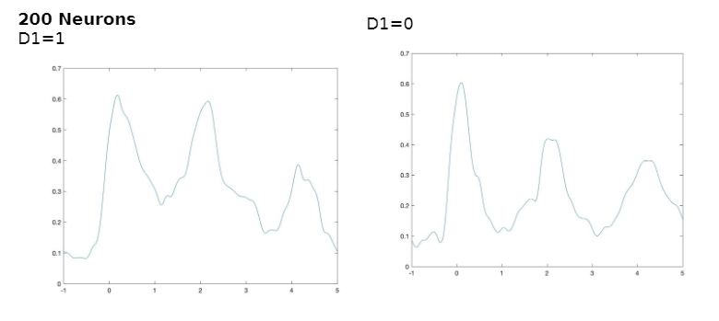

It will be good to repeat that several times, and compute standard deviation at each time point, which we should then plot as a zone around the mean line. Something like this:

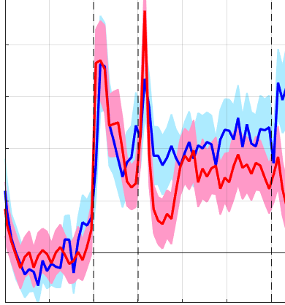

1. Effect of Neuron number
   1. Perhaps some plots like in Figure 2 side by side, plus a graph that compares one time point across all the sample sizes?

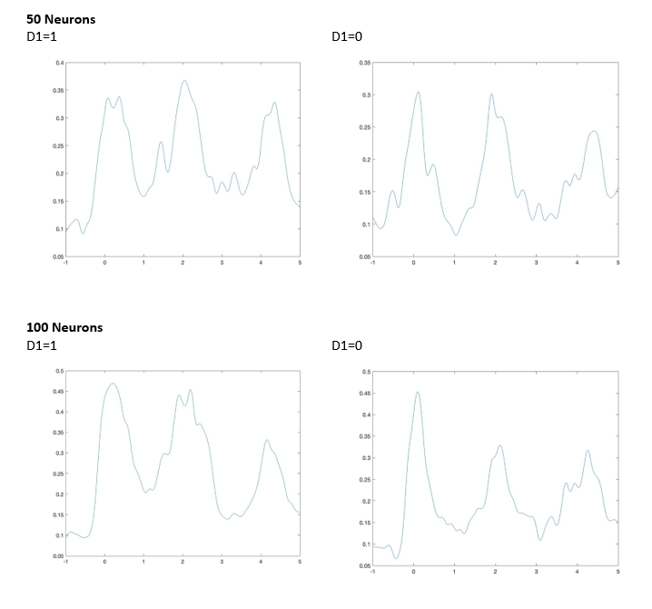 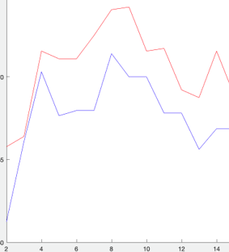

1. Effect of classifier
   1. Perhaps some plots like in Figure 2 side by side, plus a line plot that compares all the classifiers together?
2. Delay interval alone. Just a simple bar plot with individual runs and means?

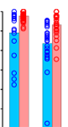

1. Feature task